Frenz Marco A. Tumangday
BSIT – 4A

Data Cleaning – Solar Eclipses

Description:
The solar-eclipses.csv dataset contains 444 records of solar eclipses spanning from 1901 to 2100, combining historical observations and predicted future eclipses. Each record includes the date, eclipse type, magnitude, duration, and the region.

Screenshot of code & Output:
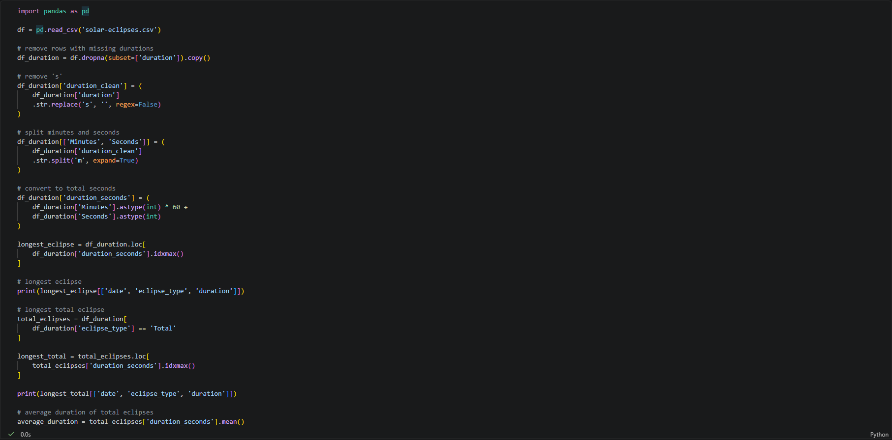
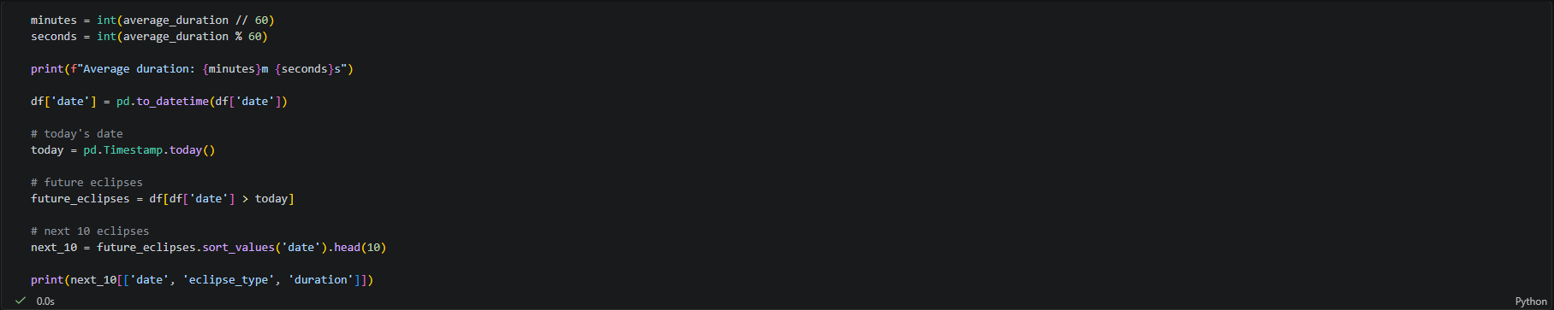
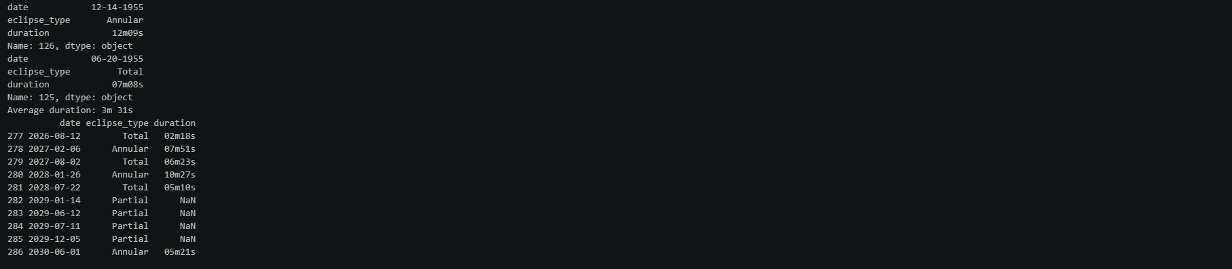

Charts:
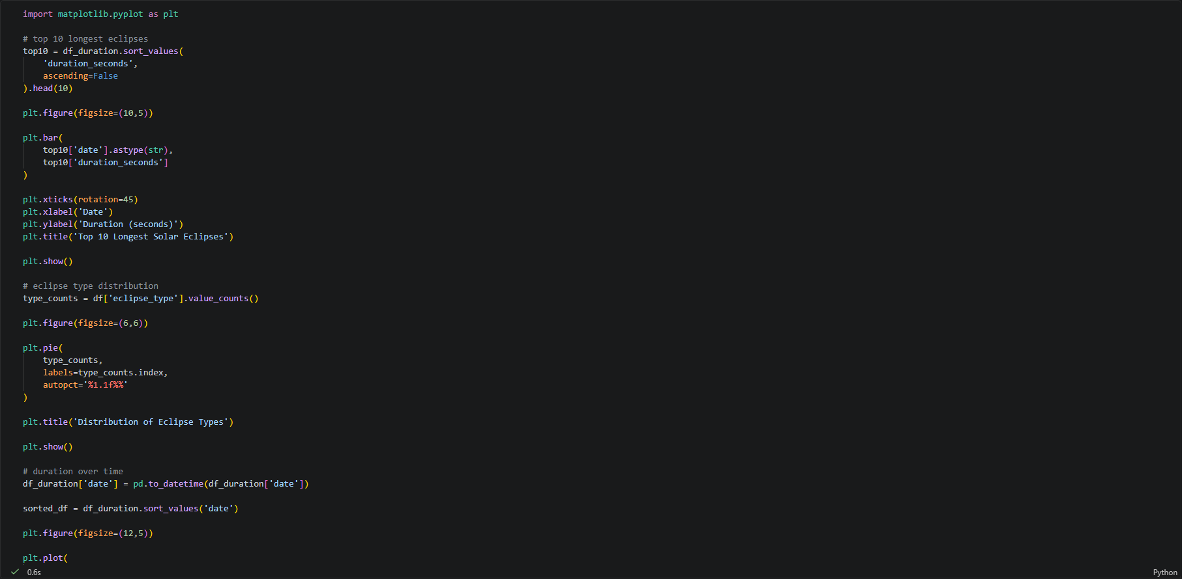
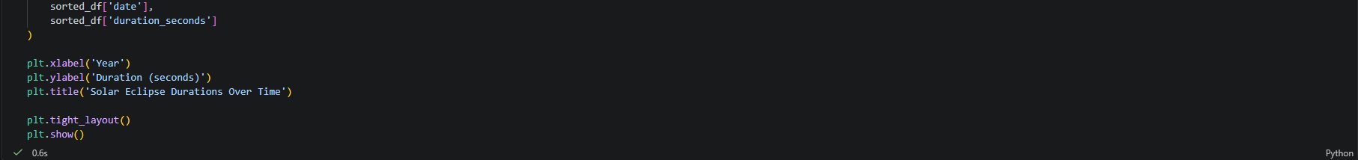
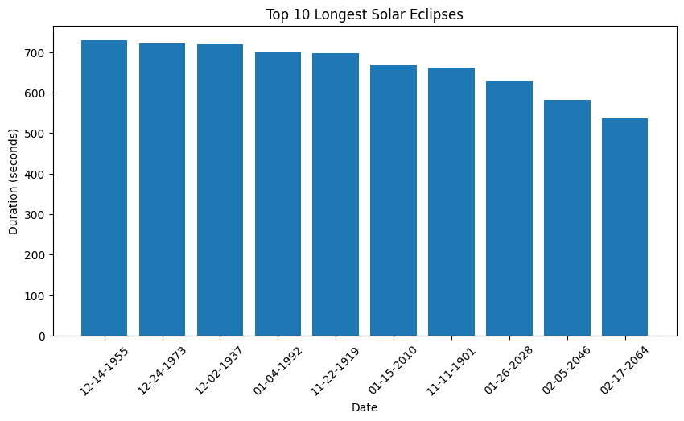
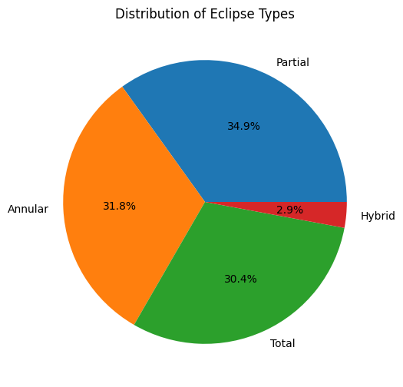
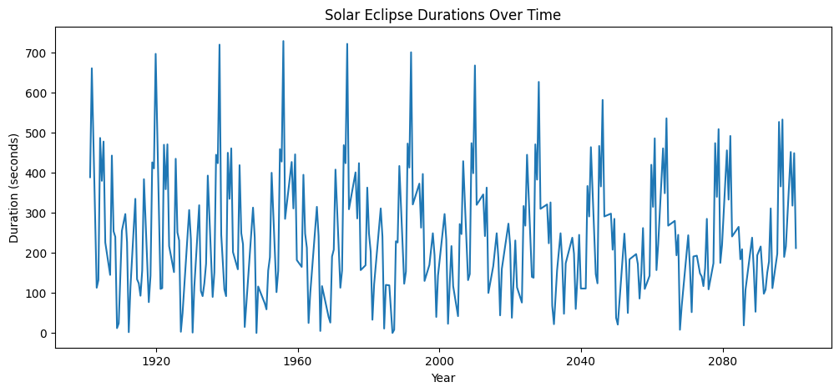

Insights/Observations:
Longest eclipse: Is an Annular eclipse on December 14, 1955, its duration was 12 minutes and 9 seconds.
Longest total eclipse: Was on June 20, 1955 at 7 minutes and 8 seconds.
Average total eclipse duration: Roughly around 3 minutes.
Next visible eclipse: Will be on August 12, 2026.

